JAPAN COMPLETE Site Plan

Kanna Murakami

WDD 130

Overview

Purpose

The purpose of "Japan Complete" is to provide international travelers with a comprehensive, one-stop resource for navigating Japan's seven major regions. Beyond basic tourism, the site aims to build "Cultural Confidence" by teaching visitors the "unspoken rules" and local etiquette necessary to respect and connect deeply with Japanese society

Audience
The target audience includes international tourists planning a trip to Japan, as well as anyone interested in learning about Japanese culture and regional diversity.

Branding

Website Logo
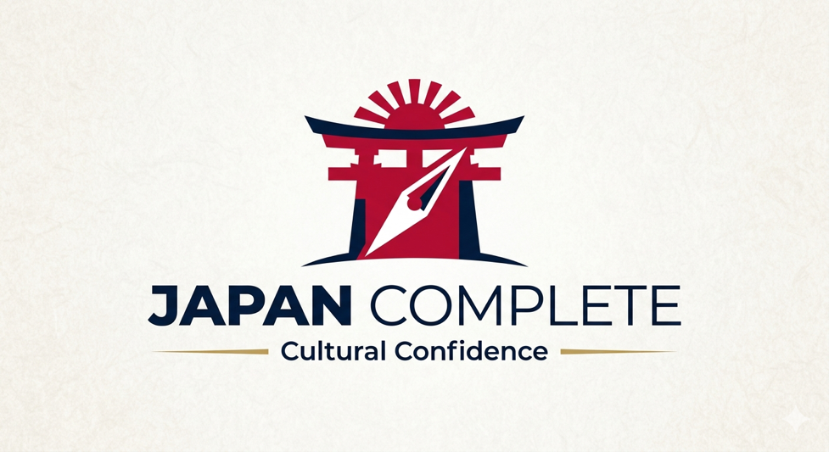

Style Guide

Color Palette
Primary | Secondary | Accent 1 | Accent 2
#F9F9F9 | #141D44 | #BC002D | #F5D5E0

Typography

Heading Font: Cal Sans

Paragraph Font: Noto Sans

Navigation
Home Explore Japan Travel Tips

Content

[put all content for the pages here, including written text and images]

Home
Travel Japan with Cultural Confidence
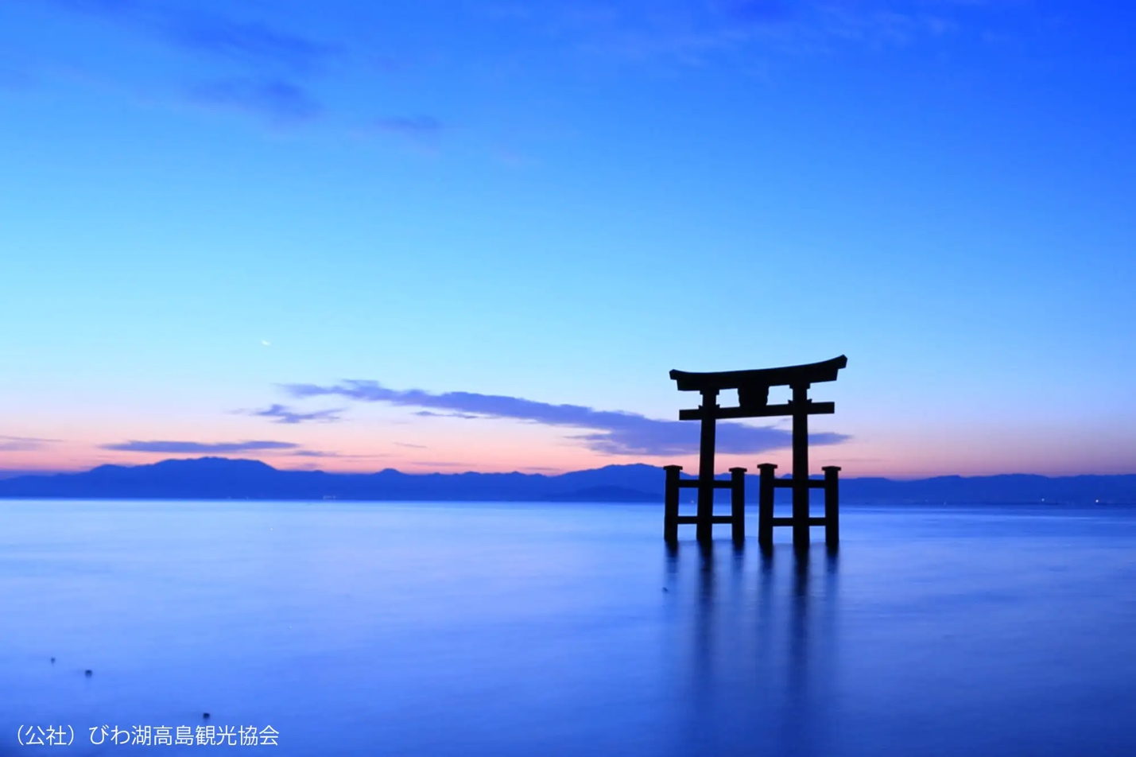
hero-img

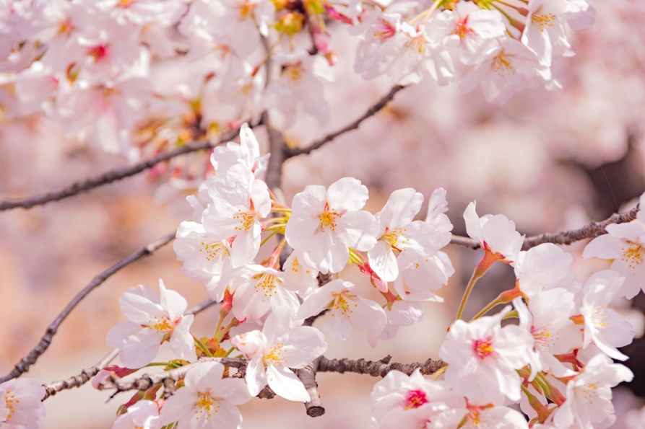
img1
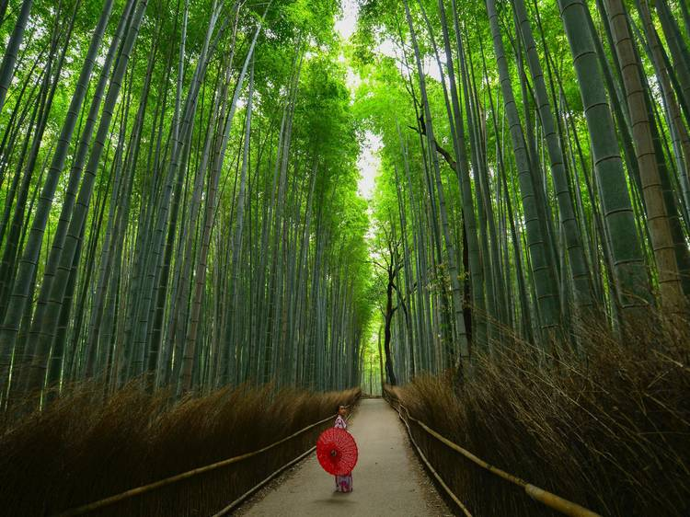
Img2
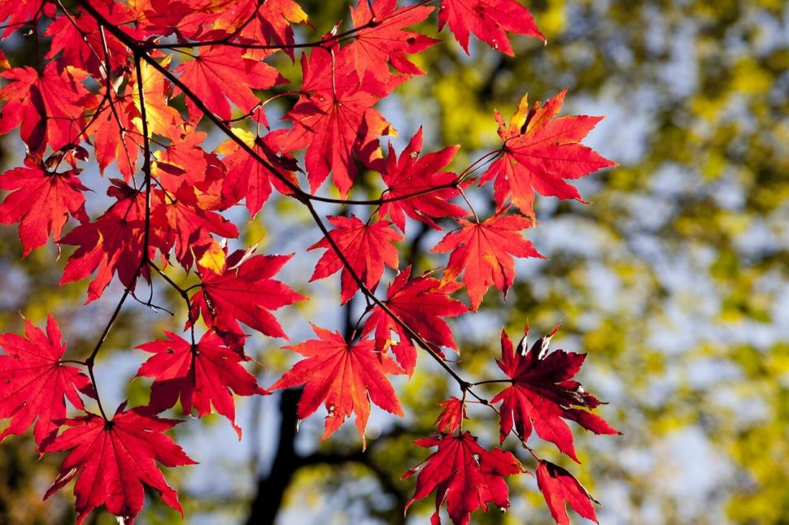
Img3

Welcome to Japan Complete, your essential guide to navigating the Land of the Rising Sun. Whether you are exploring the neon lights of Tokyo or the serene temples of Kyoto, we provide more than just a map. Our mission is to help you bridge the cultural gap with deep regional insights and essential etiquette tips, ensuring you don't just visit Japan—you connect with it.

Explore Japan

Explore Japan
Tokyo: The pulsating heart of Japan, where futuristic skyscrapers stand alongside ancient shrines.
Top 3 Must-Visit: 1. Shibuya Crossing, 2. Senso-ji Temple (Asakusa), 3. Shinjuku Gyoen National Garden.
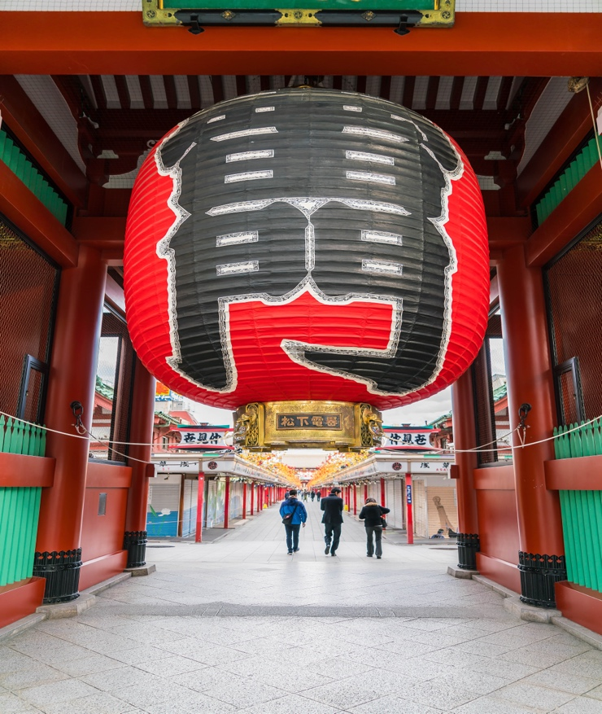
Kyoto: The cultural soul of the nation, famous for its thousands of classical Buddhist temples and exquisite gardens.
Top 3 Must-Visit: 1. Fushimi Inari Shrine, 2. Kinkaku-ji (Golden Pavilion), 3. Gion District.
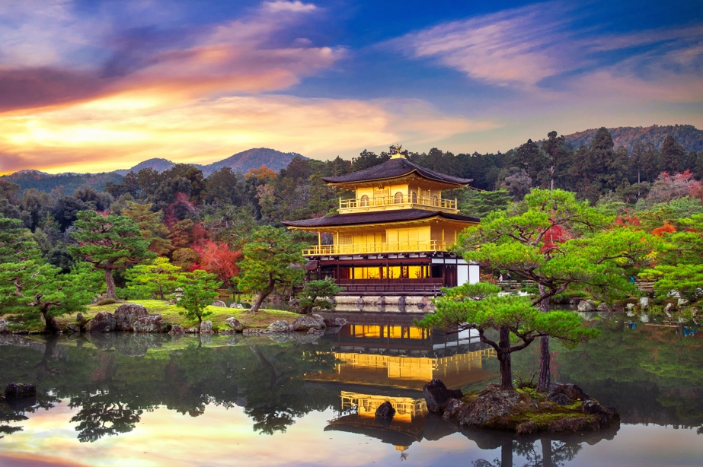
Osaka: Known for its outgoing people and incredible street food, Osaka is a city of bright lights and hearty appetites.
Top 3 Must-Visit: 1. Osaka Castle, 2. Dotonbori District, 3. Universal Studios Japan.
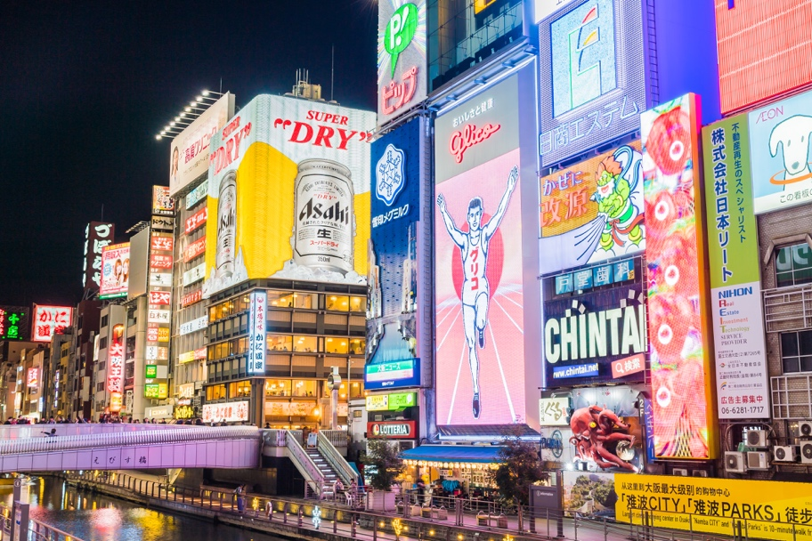
Nara: As Japan’s first permanent capital, Nara is a peaceful city where friendly deer roam free among ancient, massive wooden temples.
Top 3 Must-Visit: 1. Todai-ji Temple (Great Buddha), 2. Nara Park (Deer Park), 3. Kasuga Taisha Shrine.

Fukuoka: A vibrant coastal city famous for its warm hospitality, modern shopping malls, and world-class Hakata Ramen stalls (Yatai).
Top 3 Must-Visit: 1. Ohori Park, 2. Canal City Hakata, 3. Dazaifu Tenmangu Shrine.
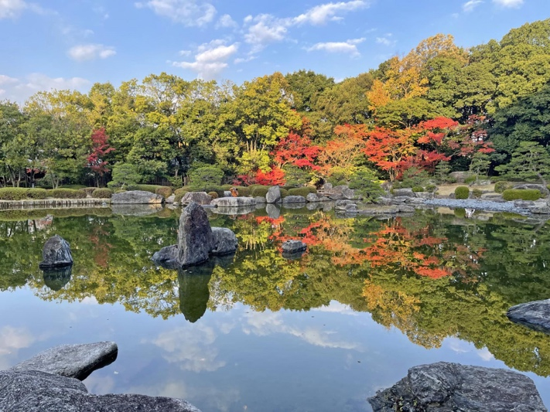
Hokkaido: Japan’s northernmost island, offering vast wilderness, snowy mountains for skiing, and the freshest seafood in the country.
Top 3 Must-Visit: 1. Odori Park (Sapporo), 2. Otaru Canal, 3. Daisetsuzan National Park.
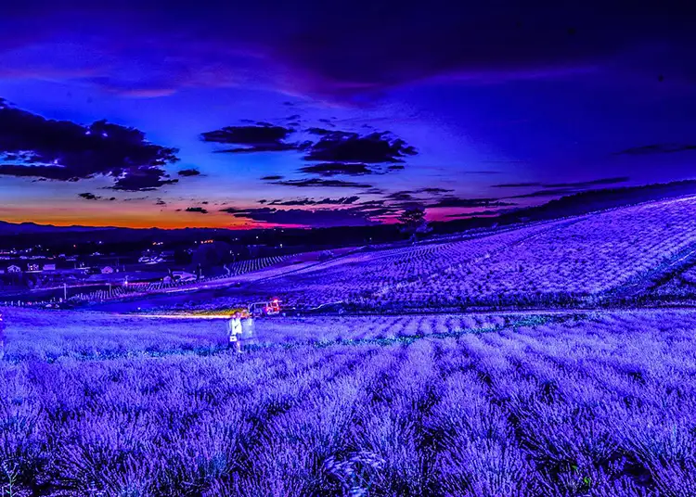
Okinawa: A chain of islands with a unique Ryukyu culture, crystal clear turquoise waters, and white sandy beaches.
Top 3 Must-Visit: 1. Churaumi Aquarium, 2. Shuri Castle, 3. Miyako Island Beaches.
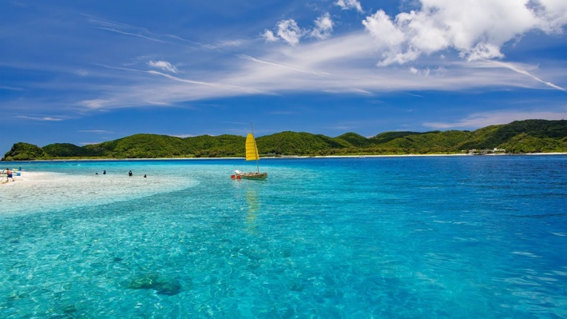

Travel Tips
Travel Tips
Rail Navigation Essentials
Decoding Train Types:
Not all trains stop at every station. Check the electronic displays for these categories:
- Local (Kakueki-teisha): Stops at every single station.
- Express / Rapid (Kyuko / Kaisoku): Skips smaller stations to get you to major hubs faster.
- Limited Express (Tokkyu): The fastest option (excluding Shinkansen), usually requiring an extra reserved seat ticket.
Platform Markings:
Look at the floor! There are marked lines indicating exactly where the train doors will open. Form an orderly queue behind these lines and wait for arriving passengers to exit completely before boarding.
The Shinkansen (Bullet Train):
For long-distance travel, use the Shinkansen. Note that these have their own dedicated gates and platforms separate from local lines. If you have large luggage, look for seats with "Oversized Baggage" reservations.
Carriage Etiquette:
Once inside, place your backpack on the overhead rack or hold it in front of you to save space for others. Avoid sitting on the floor or blocking the doors with your suitcases.

Unspoken Rules (The Etiquette Guide)
Train Silence: Keep phone calls for the platform; speaking loudly on trains is considered disrespectful.
Escalator Etiquette: Stand on the left in Tokyo and on the right in Osaka to let others pass.
Tipping: Tipping is not part of Japanese culture. A simple "Arigato" (Thank you) is the best way to show appreciation.
Trash: If you cannot find a bin nearby, please kindly carry your trash with you until you reach your hotel or a convenience store. We appreciate your cooperation in not littering, as it helps keep Japan’s beautiful streets clean for everyone to enjoy.
Cash: While digital payments are growing, many smaller temples, local shops, and traditional restaurants still only accept cash. Always carry some Yen to avoid an awkward moment at the register.

Wireframes

Home

